Sri Lanka Institute of Information
Technology

Lab Submission
< PS Lab sheet 08 >

< IT25100069 >
< A.Sinthursan >

Probability and Statistics | IT2120
B.Sc. (Hons) in Information Technology
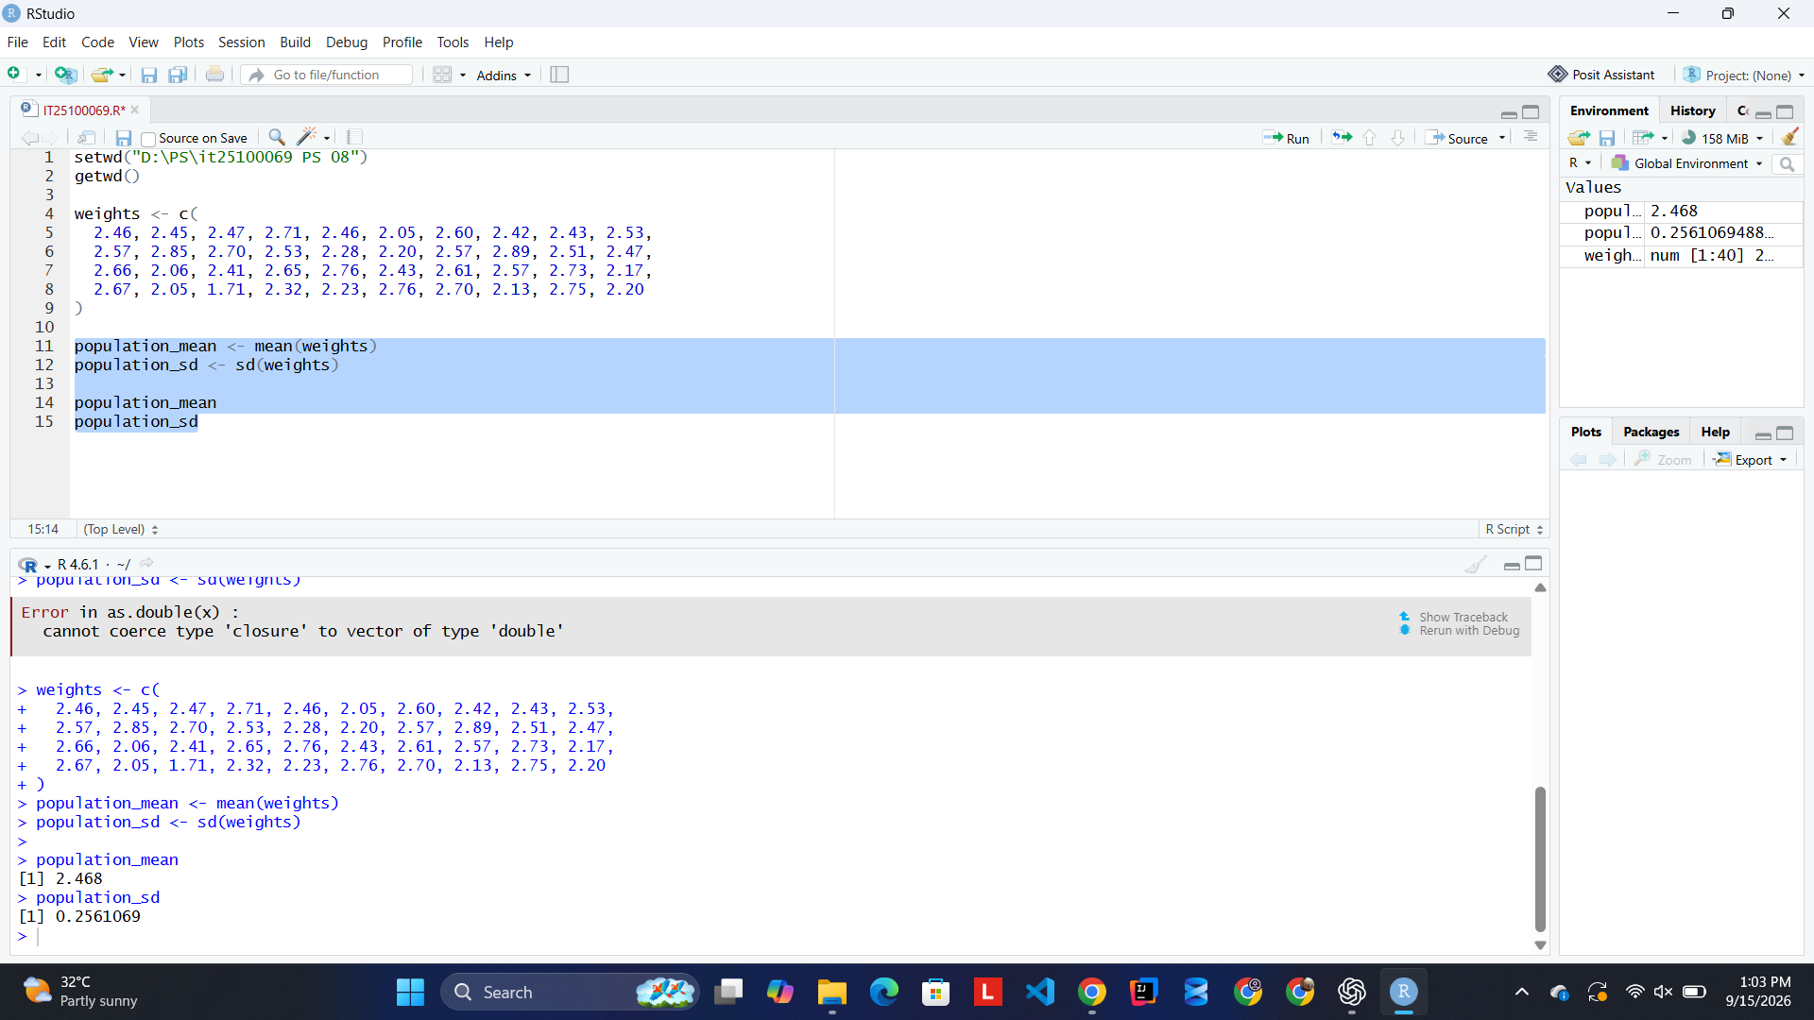
Question 1

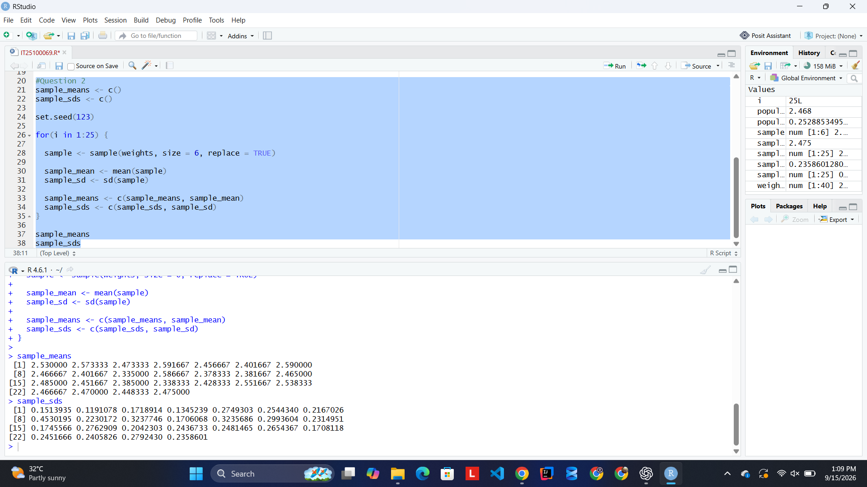
Question 2

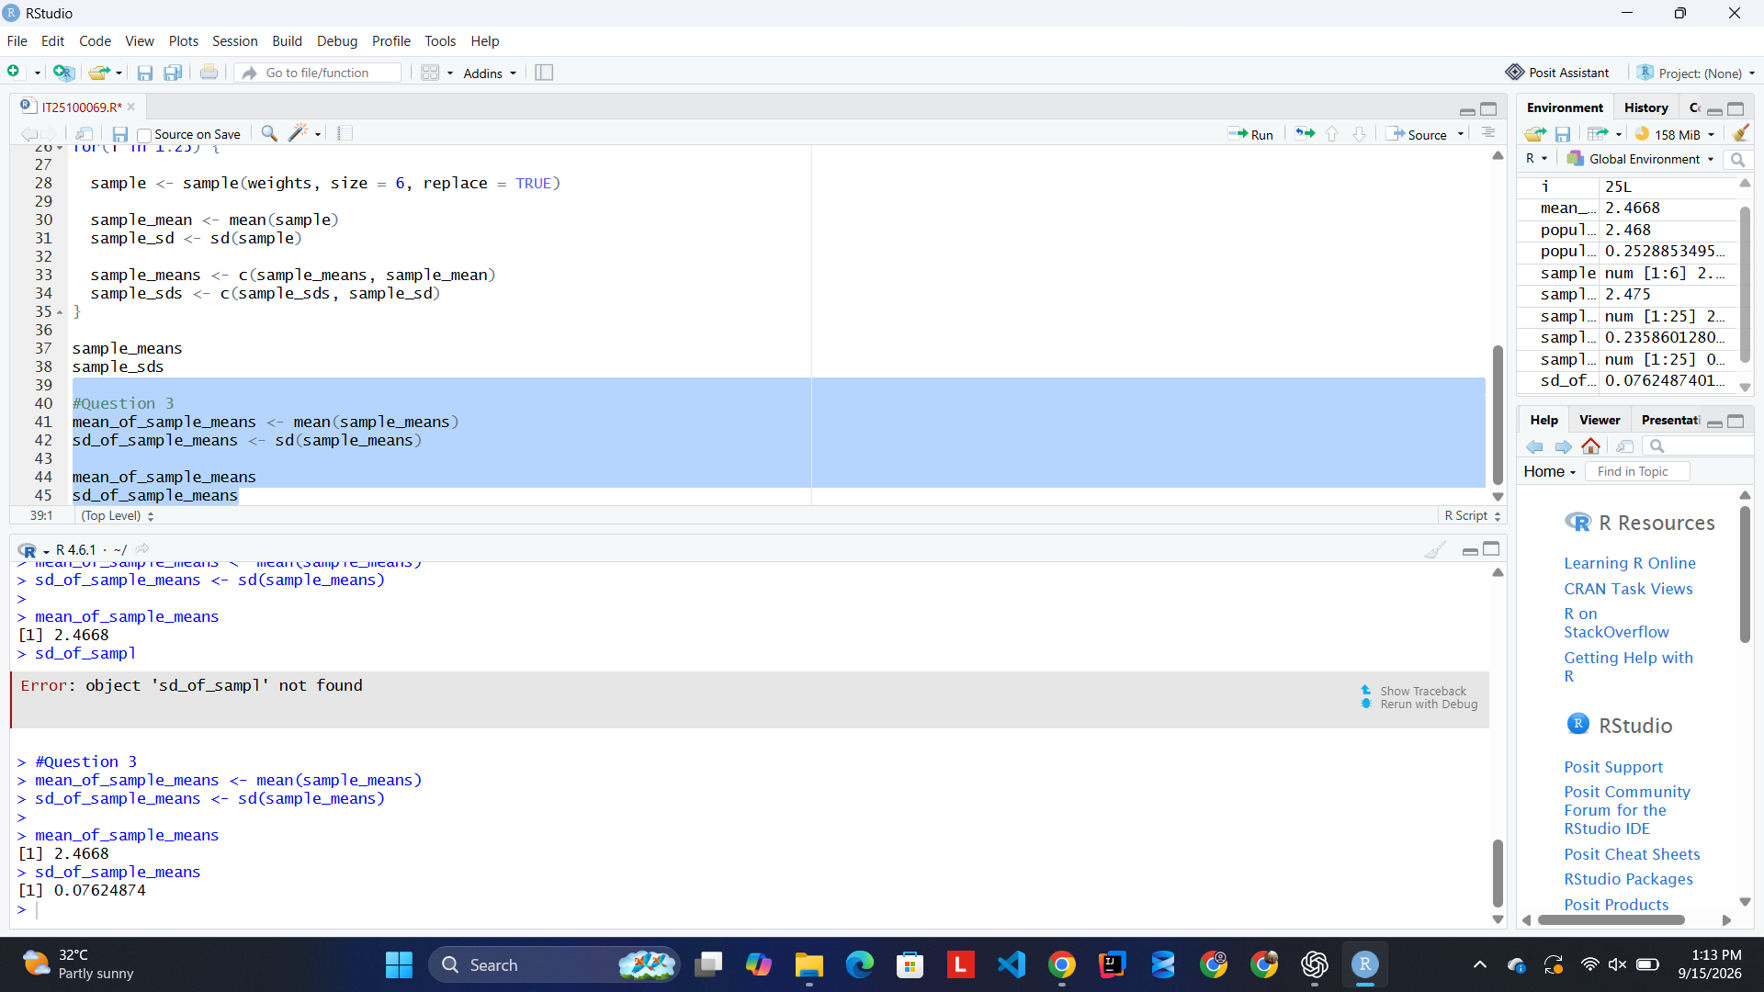
Question 3

Mean of sample means = 2.4668
Standard deviation of sample means = 0.07624874

Relationship: The mean of the sample means is approximately equal to the true population mean. The standard deviation of the sample means is smaller than the true population standard deviation.

